Program Parts

1. User Registration/Validation.

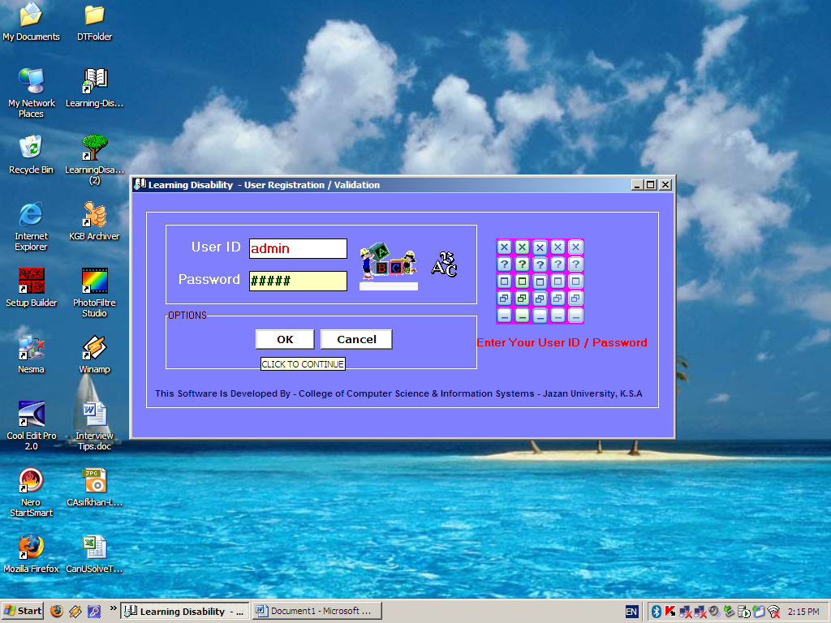

1. Admin Control.
2. Dyslexia.
   1. A B C D.
   2. Shapes
   3. Listening Skills.
   4. Select letters to make word.
   5. Choose correct word to complete sentence.
3. Dysgraphia.
   1. Identify different shapes.
   2. Pick odd one out.
4. Dyscalculia.
   1. Identify Numbers.
   2. Count Figures.
   3. Mathematical Problems.
      1. Addition/Subtraction.
      2. Number Comparison.
      3. Learn Table.
5. Reports.
   1. Daily.
   2. Weekly.
   3. From Date to Date.
6. Exit.

* Each game has 3 levels (the levels determine the pitch of the voice files).